**UNIVERSITY OF ECONOMICS AND LAW**

**FACULTY OF INFORMATION SYSTEMS**

**______________________**



**FINAL PROJECT REPORT**

**MANAGEMENT OF INFORMATION SYSTEM COURSE**

**TOPIC: E-Marketing/Digital Marketing and Information System Application in PNJ’s Retail.**

**Lecturer: Ho Trung Thanh, Ph.D.**

**Group: *5***

**Ho Chi Minh City, May 15th, 2022**

|  |  |  |  |
| --- | --- | --- | --- |
| ****Student’s ID**** | ****Student’s Name**** | ****Responsibility**** | ****Percentage of distribution**** |
| **K204162007** | **Bùi Thu Vân** | **Divide the work, complete the assigned content, do the research, presentation.** | **25%** |
| **K204161988** | **Lê Chí Hào** | **Complete the assigned content, do the research, presentation.** | **25%** |
| **K204162011** | **Trần Triệu Vy** | **Complete the assigned content, do the research, presentation.** | **25%** |
| **K204161991** | **Nguyễn Thị Ái Linh** | **Complete the assigned content, do the research, presentation.** | **25%** |

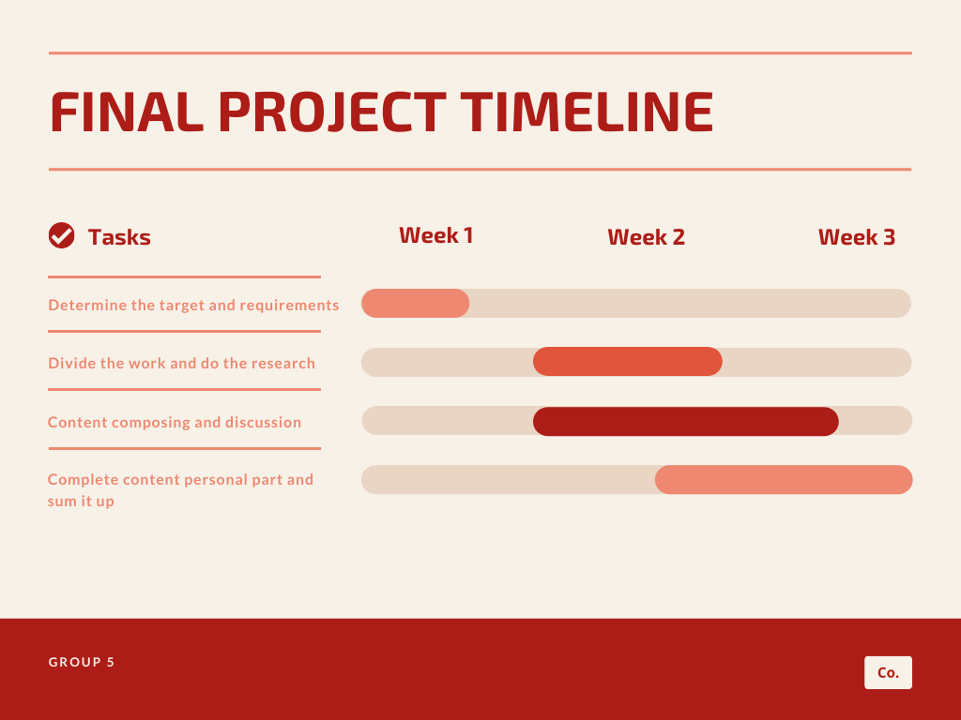

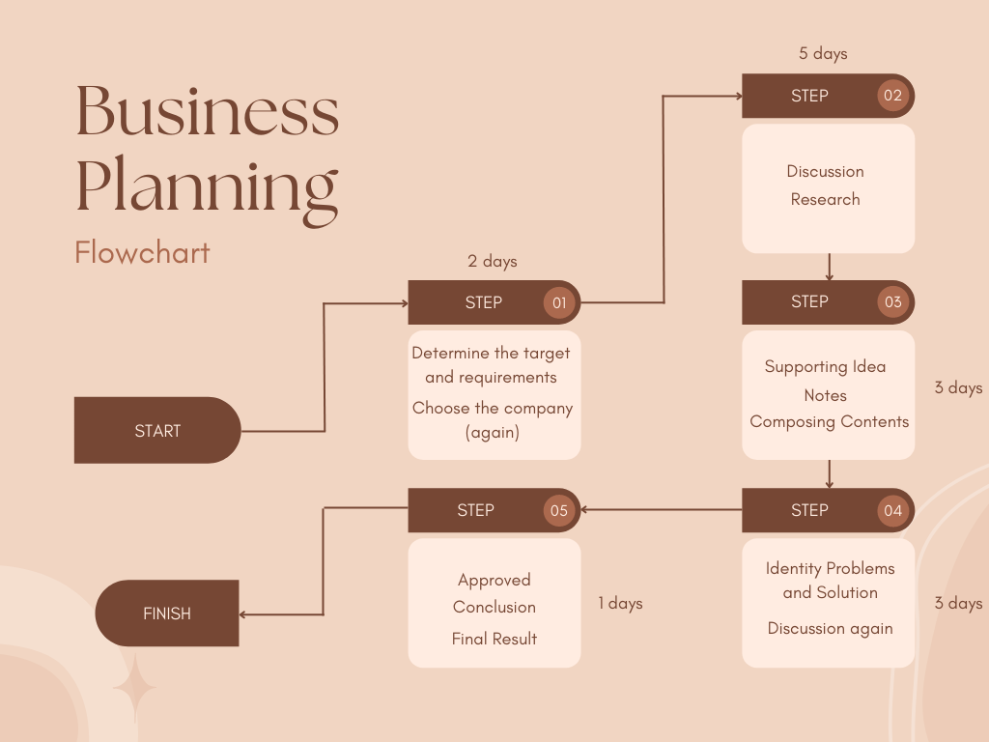

Contents

Survey and make introduction about the company 4

Analyze and describe how they use Information Systems in general for the company 6

Porter’s 5 Forces Analysis 8

**1. Competitive Rivalry - MODERATE**: 8

**2. Threat of new entrants - MODERATE**: 9

**3. Bargaining power of suppliers: LOW** 10

**4. Bargaining power of buyers: MODERATE** 11

**5. Substitute products and services: LOW** 12

Four generic strategies for dealing with competitive force enable by using Information System 13

**1. Low-cost leadership:** 13

**2. Focus on Market Niche** 16

**3. Strengthen customer and supplier intimacy:** 19

**4. Product differentiation:** 20

Explain the basic concepts 23

**1. What Is Digital Marketing?** 23

**2. What is e-marketing?** 23

**3. What is conversational marketing?** 24

Analyze and compare three solutions in the market. 25

Describe values of implementing information system solutions for management and business growth. 32

E-Marketing/Digital Marketing from PNJ and their still existing problems. 34

# Survey and make introduction about the company

Imagine, you are running a large company and it seems that your company is doing very well. I can say that your company is on top and already has a pretty strong foothold in the market. But what inevitably happens is that you cannot control the market, the market is always changing, for better or for worse for your company. I don't know how the upcoming change will affect your company, how will you handle it? Accept to keep everything available because you already own a well-functioning machine? Or take big risks to change, even though you are already one of the top people in the field? It's hard to decide right? But with PNJ - a leading jewelry manufacturing and retail business in Asia, restructuring is always on top. Employees only see that: "the company is doing well, forcing me to restructure, forcing me to change", but with the owner's mindset: "change or die?", "if you don't change, you have to stay out of the game," said Ms. Cao Thi Ngoc Dung - Chairman of the Board of Directors of PNJ.

That's the story of PNJ's change, but first let's learn a little about PNJ!

PNJ is one of the leading enterprises of the jewelry manufacturing and trading industry in Vietnam and one of the major enterprises in the region with the awards "Top 500 leading retailers in Asia Pacific", identifying set the record of "The first enterprise to invest in the most modern and largest-scale jewelry production technology in Vietnam". You may only know PNJ as a jewelry trading company, but actually PNJ is a multi-industry company investing capital in the fields of finance, real estate, tourism, entertainment industry, and energy. and food, but in which jewelry business is the core.

The predecessor of PNJ is the Jewelry Store of Phu Nhuan District, established on April 28, 1988, under the People's Committee of Phu Nhuan District. In 1992, the Company changed its name to Phu Nhuan Jewelry Company. Entrepreneur Cao Thi Ngoc Dung is the President, General Director and founder of Phu Nhuan Jewelry Joint Stock Company (PNJ).

- 1988-1992: PNJ was born and took production and business of professional exports as a development strategy.

- 1993-2000: Accelerating the expansion of networks and industries, building the company's brand.

- 2001-2004: Promote brand building and implement equitization

- 2005-2008: Re-branding and developing luxury brands, launching a brand

CAO Fine Jewellery

- 2009-2011: There was a growth in size and brand

- 2012-2017: Restructuring for lasting development

Back to the transformation story of PNJ, at present, many Vietnamese enterprises are developing unsustainably, because we are afraid of restructuring. Many people fear that transformation will lose what is sustainable, how breakthrough will it be… The founder's ideology will determine the culture and development path of the business. Therefore, if you want to restructure a company, you must first restructure the owner's mind.

And especially, while many businesses are in dire straits, sharply reducing their revenue, doing business at a loss, or even going bankrupt because of the impact of Covid-19, PNJ, a production and business enterprise, is considered as " non-essential" saw a spectacular growth in profit, up to 50-60% over the same period. In fact, consumer interest in jewelry and gems has never disappeared. As explained by Mr. Phan Quoc Kiet, Omnichannel Sales Manager, PNJ, customer demand is like a pent-up spring and just waiting for the right opportunity to pop up. PNJ's products are more emotional inside, users want to feel the direct experience…. Besides, before deciding to buy, customers often research very carefully and experience on many channels. And thanks to the long-established home delivery method, contributing about 30% of online channel sales.

Besides, the Click and Collect form has been very popular in the past 2 years with strong sales, accounting for 70% and high invoice value. PNJ expects the online channel to contribute more to the system in the next 3-5 years with the goal of accounting for about 10-15% of total sales.

Not only that, Covid-19 limits human communication activities, which causes many inconveniences. However, over time, businesses, especially small and medium enterprises, understand the importance and ways that messaging technology is changing human communication, thereby building effective business strategies. As more and more people choose to shop through social channels, businesses will create conversational technologies that help them connect more and more effectively with customers.

By launching Charmy, an automated experience built on Messenger, PNJ was able to engage in personalized conversations with customers, respond to inquiries, and recommend products. High-class products with the same detail and dedication as direct consultation at the store.

# Analyze and describe how they use Information Systems in general for the company

Starting to implement restructuring in 2013, in 2019 PNJ continues the philosophy of "restructuring on top", putting into operation an $8.3 million ERP - the management system is associated with 3 months of the crisis of the company. PNJ and all the securities companies called the "ERP crash" later. As a large enterprise with a high ERP budget, PNJ started moving from in-house ERP to the SAP-powered system, after realizing the limitations of the old system during retail expansion. According to analysts, the total investment of PNJ for the new system is approximately tens of millions of USD, including royalties, consulting fees, implementation fees...

From there, enhancing the experience for customers, not only bringing them beauty products but also giving them spiritual values. Therefore, ERP solution helps to connect all activities into one system, planning and managing resources, providing overall and unified information; At the same time, it helps PNJ to take better care of customers.

Regarding the enterprise human resource planning project - ERP of PNJ, Ms. Josephine Galla, representative of SAP, said that SAP 4HANA is the latest generation ERP technology - a completely new version of intelligent ERP and PNJ is the first unit to implement this project in Vietnam.

SAP will have many more projects to support PNJ such as interaction management, connection, and understanding of customer needs... to provide PNJ customers with the best products and experiences.

Especially, with the ERP platform as well as the component projects of the Digital Transformation strategy, PNJ will make a revolution in business activities for the company in the future.

After the time of operation effort since the time of golive on April 2nd, 2019, the ERP system - SAP4HANA has been put into stable operation and become a powerful tool to help PNJ manage and maximize the potential resources, create a comprehensive strength for the business on the basis of strengthening production capacity, supply chain management, inventory optimization, strategic management, marketing, ... The resources will be optimized and utilized the full potential to accelerate the speed of market domination, creating the momentum for long-term strides in the future. One of the initial highlights of the project is that Data Analytics technology which has analyzed and optimized inventory as well as moving volumes. In parallel, Computer Vision technology combined with artificial intelligence has turned security cameras into tools to read customer and employee behaviors in order to make necessary adjustments to the arrangement of counters and shelves, which facilitates the flow of customers, optimizes customers service activities. Along with data analysis, consumer behavior to understand the needs, stay ahead of the trend and develop e-commerce, PNJ has promised a strong breakthrough. This process has been carried out in parallel with the enrichment of human resources, brand resources, customer resources, etc. as well as preparing human resources with sufficient knowledge, experience in analyzing and using data in business activities, strongly bringing PNJ into the era of retail 4.0.

However, with today's new architecture and technology, it will automatically measure the amount of user traffic, system load, and a number of transactions and will automatically scale without any prior preparation of physical resources. physical… With a retail chain of more than 350 stores like PNJ, the problem of optimizing the cost of store technology infrastructure such as POS (point of sale), purchasing, and selling systems via POS is very important. In addition, when user traffic spikes during the peak season (4-5 times), PNJ's new system on AWS's Cloud platform can dynamically expand automatically. Implement key technology projects: Successfully Go-live SaP, system transfer, and troubleshooting during the operation phase, increasingly grasp and apply ERP platform, increase productivity and ensure on-time delivery rate. Currently continuing to improve the system to operate more efficiently.

PNJ has also used carousel video and photo ads alongside dynamic ads introducing premium product lines. These reports helped PNJ display information individually to each audience, based on the products they viewed or the websites they visited previously. In addition, with the goal of capturing the impact of Messenger conversations on sales, PNJ used the Facebook pixel to measure online sales combined with the Offline conversion API to track the number of purchases right at the store. Besides, the free shipping program is applied and customers receive products only after 4 hours. These factors have helped PNJ increase sales online and in person.

# Porter’s 5 Forces Analysis

## **1. Competitive Rivalry - MODERATE**:

The whole country has about 10,000 shops selling jewelry, but for the jewelry market of Vietnam, there is not a big brand that is considered to be able to dominate the market. Big brands like PNJ, SJC, Bao Tin Minh Chau also only account for a small share of the total market. More and more famous foreign jewelry brands have gradually entered the Vietnamese market and are also mainly concentrated in the area of ​​Ben Thanh Market, Saigon Jewelry Center.

Industry competitors:

1. DOJI Jewelry Brand

- Thanks to the distribution system spreading from North to South combined with beautiful designs, novelty, and reasonable price, DOJI has gradually strengthened its position in the hearts of customers.

- Enterprises also focus on product quality and campaigns marketing with the goal of bringing jewelry products into demand essential in modern life.

1. SJC - Saigon Jewelry Company Limited

The SJC brand that has entered the minds of customers is a product of trust, prestige, and quality. Deserving of the title of National brand, SJC products are diversified with many categories from popular to high-end, divided into 2 product lines: the popular SJC jewelry line and the high-end SJC Diagold jewelry line with many Unique and fashionable designs from casting, punching, wiring, machine engraving... The price is moderate, suitable for many customers and meets the needs of agency stores in the provinces. in the country.

In which, SJC is the most formidable competitor because:

- As one of the leading corporations in the gold, silver and gems market in Vietnam

- Total equity in parent company is quite large (255.16 billion, as of 2010)

- Distribution system throughout cities and urban areas throughout the country.

- There are many promotional methods that bring good response from customers

- Know how to create a brand or make an impression on consumers by organizing auction events in addition to producing beautiful, good-quality products.

- Customer care service also receives high satisfaction such as the policy of wholesale, retail or member accumulation.

Foreign companies:

Pranda Thailand Company - a subsidiary of a large jewelry group of Thailand, producing jewelry with 100% foreign capital is operating on a large scale in the South (Dong Nai).

Merii (France) the first store opened on the 1st floor of Takashimaya Department Store. Merii jewelry represents sophistication, sensuality and fashion with feminine and dynamic product lines. In particular, modern ladies will be hard to refuse because of the extremely reasonable prices along with the designs that are always updated with the latest fashion trends.

Muchas J. was established in 1994 in Singapore. With a passion for design in simple and elegant lines. Muchas J. jewelry and accessories always bring a special and feminine fashion style. Muchas J.'s products are created with care and skill. Each product is perfect and meticulously crafted with premium materials such as Swarovski crystals.

Some other retail businesses.

- Big brands have a brand advantage, while retailers have price advantage. They will hit the psyche of the people in the midrange.

- These businesses are also promoting the building of chain systems retail stores and product development marketing campaigns in eecently, profit from this business segment has increased significantly.

According to the ASEAN - China Free Trade Agreement; ASEAN- Korea; ASEAN - Japan, by 2018, the import tax rate of gold jewelry and fine arts from these countries into ASEAN countries will be reduced to 0%. Meanwhile, imported gold jewelry and fine art products have diverse designs, beautiful designs, low prices, etc., so they will have more competitive advantages than domestic products. Therefore, if PNJ does not continue to improve production capacity, manage production and business costs, and continuously innovate product designs, PNJ's ambition to develop jewelry market share may be lost. strong influence, although now PNJ is the leading jewelry manufacturer and trader in Vietnam. That's not to mention now a number of major domestic competitors such as SJC, DOJI, ... have also been promoting the development of jewelry.

## **2. Threat of new entrants - MODERATE**:

Leading the current gold jewelry market is not the "big guys" in the gold industry such as PNJ, Doji, Bao Tin Minh Chau, Phu Quy..., but the traditional retail gold shops with the concept of gold jewelry. Fashion is a product purchased for the sole purpose of making jewelry for oneself or giving as a gift, not for the purpose of hoarding.

Therefore, most people with average incomes often go to small stores to buy products that suit their needs and budget.

Private businesses and shops have the following characteristics:

- Small organization size, not high management level

- Financial potential is quite good

- Much of the business is based on trust

- This system is accounting for 80% of the market share of popular jewelry

Meanwhile, the jewelry products of the branded businesses are mainly for fashion trendsetters and the middle class, with high income.

However, over time, these businesses have launched products with simple designs made almost entirely or entirely of gold instead of mixed with other precious stones or precious metals, sold with a small processing fee and the cost of gold raw materials, so that the product price is cheaper, gaining more favor with customers.

## **3. Bargaining power of suppliers: LOW**

Suppliers can be viewed as a threat as they can force prices to increase or reduce the quality requirements of the inputs they supply to the company, thereby reducing the profitability of the company. According to Porter, suppliers are most powerful when: “The product a supplier sells is least likely to be substituted and is important to the company.”

The input materials of PNJ are raw gold, raw silver, gold bars, gemstones and diamonds, imported from domestic and foreign sources. Due to regulations restricting import of gold bars from the State Bank, PNJ's main source of gold is purchased in the domestic market for recycling and jewelry production. Gold is influenced by the law of supply and demand in the market as well as by the domestic and foreign currencies that buy it, which are mainly USD. Therefore, the suppliers cannot determine the price of gold in the market.

The abundant domestic sources of gold. Vietnam’s inflation rate in 2015 is among the lowest in the Southeast Asian region, at only 0.6%. This inflation rate is forecast to experience a stably low trend. The low inflation rate reduces consumers’ incentive to keep gold as a form of investment. In other words, the domestic source of gold will slightly increase thanks to the low inflation rate of the economy.

PNJ mainly imports raw silver through a number of suppliers in Belgium. Regarding gemstones, PNJ imports mainly from Thailand and Hong Kong. In addition, PNJ imports diamonds from many different sources and is closely tested. The raw materials supplied by the suppliers are fairly standardized, less differentiated and have low switching costs. This helps PNJ to switch suppliers more easily, making the bargaining power of suppliers weak.

Moreover, the industry that PNJ does business in is an important customer of suppliers. This means that industry profits are tied to the margins of the suppliers.

In addition, in order to be effective in increasing revenue as well as attracting customers, PNJ is also having promotional activities such as: Buy with 0% interest installment payment or love combo with love price or some other forms. other promotions. PNJ can use its threat against suppliers because of PNJ's position as the leading jewelry retailer in the market and national iconic brand, they can use this ability as a tool to lead to discounts. This weakens the power of suppliers.

Therefore, the bargaining of suppliers in the jewelry industry is low.

## **4. Bargaining power of buyers: MODERATE**

PNJ occupies nearly 40% market share in the gold, silver and gem jewelry making and retail market in Vietnam with production capacity of over 4 million products per year. Jewelry products crafted by PNJ have been distributed directly to millions of customers through nearly 400 retail stores, e-commerce channels and indirectly through more than 3,000 wholesale customers nationwide as well as has been exported to 13 countries and regions. Through that, PNJ has clear policies for easy supervision and business.

Specifically, PNJ has a clear exchange policy and warranty policy for their products. For example, for all kinds of jewelry, the repurchase rate is between 50% and 80% and the exchange rate is from 60% to 90%. Therefore, customers must comply with PNJ's policy and have no right to deal prices.

According to the Association of IHigh Quality Vietnamese Goods in 2019, PNJ won the title of high quality Vietnamese goods for 22 consecutive years. From there, it can be seen that the quality of PNJ's products has been recognized by consumers, and PNJ has brought itself a large number of loyal customers.

On the other hand, taking into consideration the key characteristics of consumers in the mass luxury market, a majority of which are middle – income class, pricing is of paramount importance for the consumers to make their purchasing decision. Coupled with an intimate relationship with the unorganized players, higher price is another barrier for PNJ to get more familiar with the consumers.

We assess the combination of these 2 factors implying a moderate threat.

## **5. Substitute products and services: LOW**

Products from different materials in the luxury industry possess unique traits and contain different meanings. Therefore, we assess that the company faces insignificant risk from substitutes. According to OECD, Vietnam is placed lastly among the current middle-income countries in Emerging Asia to reach high income status, along with India. It takes Vietnam about 38 years to leaver middle-income group, which is 7.6 times longer than Malaysia, 3.2 times longer

than China and 2 times longer than Thailand. With a low shift from middle income into high income of the Vietnamese consumers, we strongly believe that

the customer base of each type of products, including gold and silver jewelry, diamond and other gem jewelries will not change over the medium term.

Besides, due to the traditional habits of Vietnamese people, gold and silver jewelry products are difficult to replace in holidays, Tet, weddings... Gold is considered a valuable and valuable asset. High liquidity and difficult to fluctuate, so in addition to being used for beauty purposes, it is also used for storage purposes.

But if the gold, silver, and gem markets are unstable, and the stocks of businesses in the gold and silver industry go down, people can turn to investing in securities, real estate, with the same value. In fact, real estate is often a substitute for gold, silver, and precious stones. But today, people are turning to lucrative trends with these activities as an alternative to buying gold just for jewelry. When they find this market unprofitable they will switch to other forms of business.

However, in general, it is very difficult for any product to replace the position of gold, silver and precious stones, because people's beliefs and habits in gold, silver, and precious stones have existed for a long time. Combined with the above analysis, we assess the threat of Substitute is LOW.



# Four generic strategies for dealing with competitive force enable by using Information System

## **1. Low-cost leadership:**

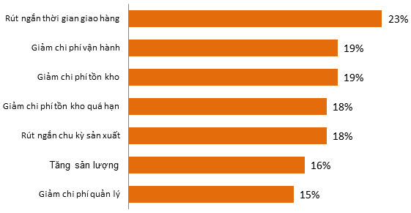

According to a survey, 46% of enterprises applying ERP have a return on investment (ROI) growth in the first 1-2 years, 30% in 2-3 years, and 24% in 3-5 years. Source: Mint Jutras, compiled by VDSC. However, when applying ERP in Vietnam, it is very "difficult", if the enterprise has not had or built a working process that is not tight enough before, the difference in business operation after applying ERP is huge. , the more difficult the implementation will be, the failure is understandable. The next difficulty comes from the person who is "in charge of the pole". problems at the enterprise) to request handling, lack of thoroughness, and practical depth leads to many obstacles in the transformation process.

Indeed, the ERP incident is one of the typical incidents of Vietnamese enterprises when applying ERP, officially implementing SAP from the end of March 2019. In April, the factory was only operating at 50% capacity, leading to a shortage of goods. In the three months of April, May, and June, PNJ's stock price was below the threshold of 75,000 VND/share for many days, a loss of 100 billion VND as expected. However, very quickly from the second half of July, PNJ's stock price showed signs of recovery

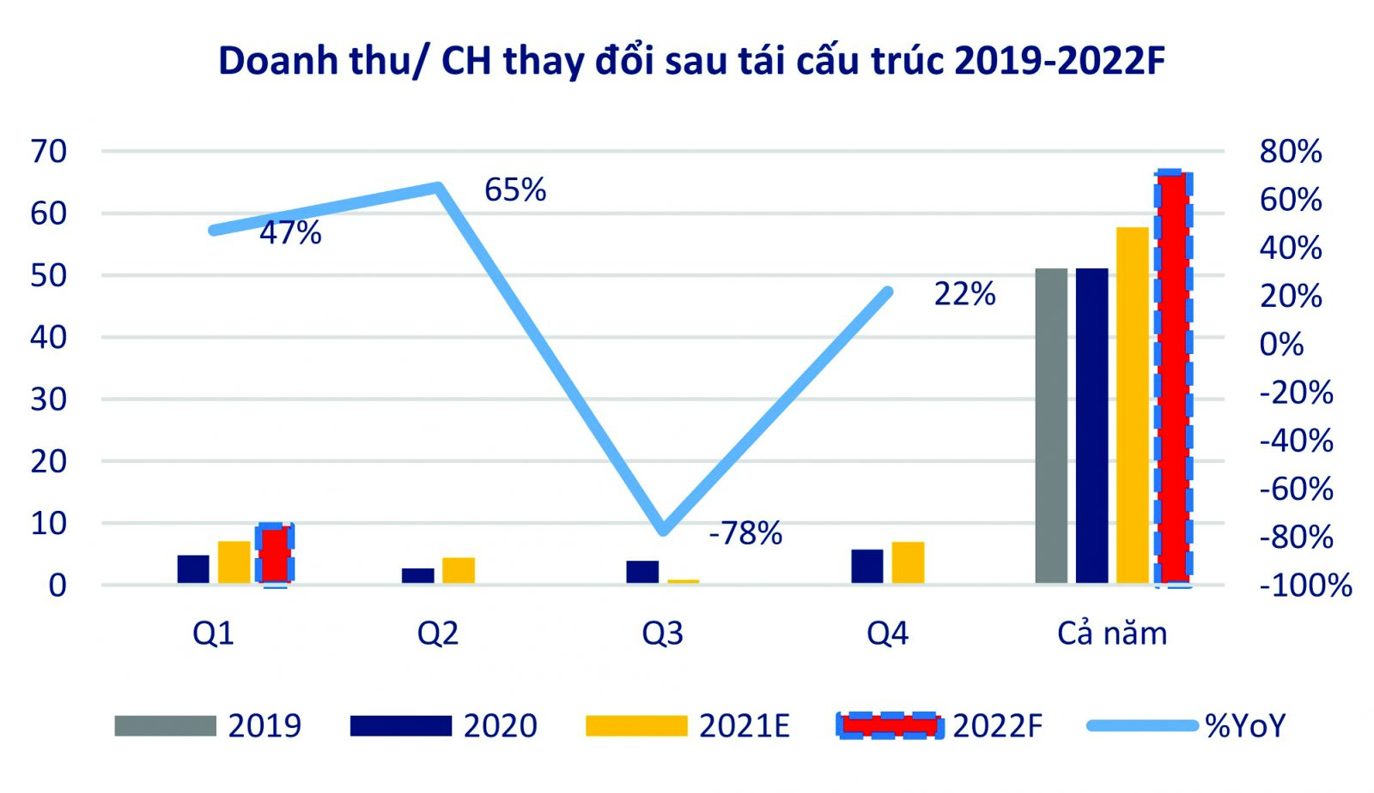

And as expected, in the past 2020, PNJ has shown flexible and effective response ability when performing a spectacular comeback. The business still maintained its growth momentum compared to the general strong decline of the jewelry market when net revenue reached VND 17,511 billion, up 3% over the same period and exceeding 21% compared to the plan. The process of effective cost management and optimization of production processes, increased accuracy in the supply of goods from the warehouse to the store, etc. helped PNJ earn VND 1,069 billion in profit after tax, exceeding 28 % compared to the set plan. Retail sales increased by 10.2% and gold bar revenue grew by 11% compared to 2019. In 2020, PNJ's gross profit margin remained at 19.6%.

In 2021, PNJ achieved VND 19,547.1 billion in net revenue and VND 1,029 billion in profit after tax, completing 93.1% and 88.9% of the target, respectively.

In addition, the application of technology solutions such as AWS's cloud has brought significant value, reduced operating investment costs, and met the large expansion and growth needs of the high season market. point. With a retail chain of more than 350 stores like PNJ, the problem of optimizing the cost of store technology infrastructure such as POS (point of sale), purchasing, and selling systems via POS is very important. Specifically, according to the financial statements of PNJ, as of June this year, the company has completed 60% of the plan, reaching 11,637 billion VND and profit after tax is 736 billion VND. This is a growth rate of about 50-60% over the same period.

When the application of cloud solutions has not been applied, before the peak period such as Valentine's Day February 14, or International Women's Day March 8, PNJ must backup, prepare more resources, add more servers, standardize additional RAM, or system storage. However, with today's new architecture and technology, it will automatically measure the amount of user traffic, system load, and a number of transactions and will automatically scale without any prior preparation of physical resources. Besides, the payment, expansion of the development scale is also very simple. AWS's platform along with the applications PNJ built on the platform has helped shorten the transaction time. The application of this new technology has greatly increased customer experience as well as a much higher closing rate.

## **2. Focus on Market Niche**

Regarding sales strategy, in previous years, PNJ followed the trend of "bombing the carpet". This means that a year they run up to 6 major shows across the country. But in 2020, PNJ has significantly reduced communication costs to protect liquidity.

In a month, PNJ conducts 4 sales programs, targeting a specific group of customers but will have to "shoot accurately".



During the 2020 New Year season, Facebook chose PNJ as a typical case of the application of Conversational Marketing that helped PNJ's ROI (Return on investment up to 153 times. To check whether Messenger can do this navigation and increase sales, PNJ ran a Conversational Commerce ad campaign for the line of Feng Shui Jewelry tailored to each specific audience group. With the campaign, PNJ implemented a "Click to Messenger'' button. The campaign used advertising forms such as Carousel format and dynamic ads to introduce high-end jewelry lines. Effective measurement and control, PNJ and Nousa use the Pixel system from Facebook and automatically link it with the customer information system, so that the results can not only measure online sales, but also measure online sales. In-store sales are also measured.

The campaign runs for six weeks and targets customers between the ages of 23-45, living in Vietnam. In addition, the custom audience includes website visitors and people who have contacted PNJ within the previous 60 days. And the expanded customer file includes customers who bought jewelry at one of the PNJ stores.

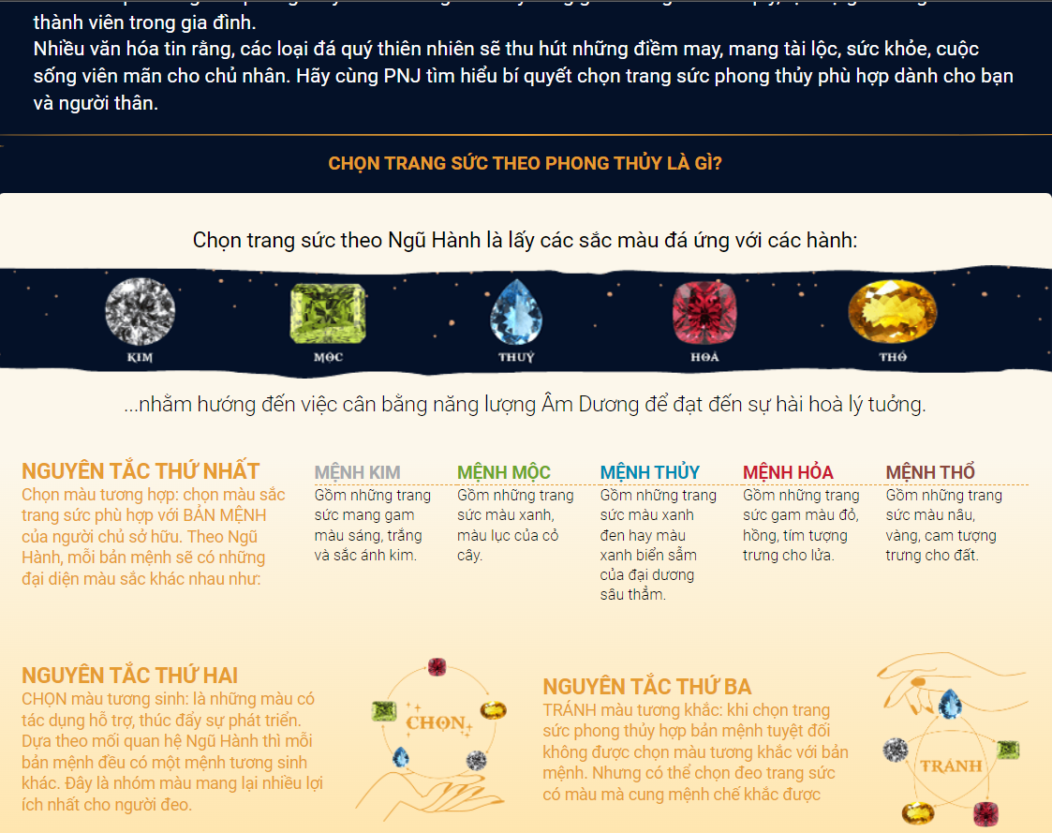

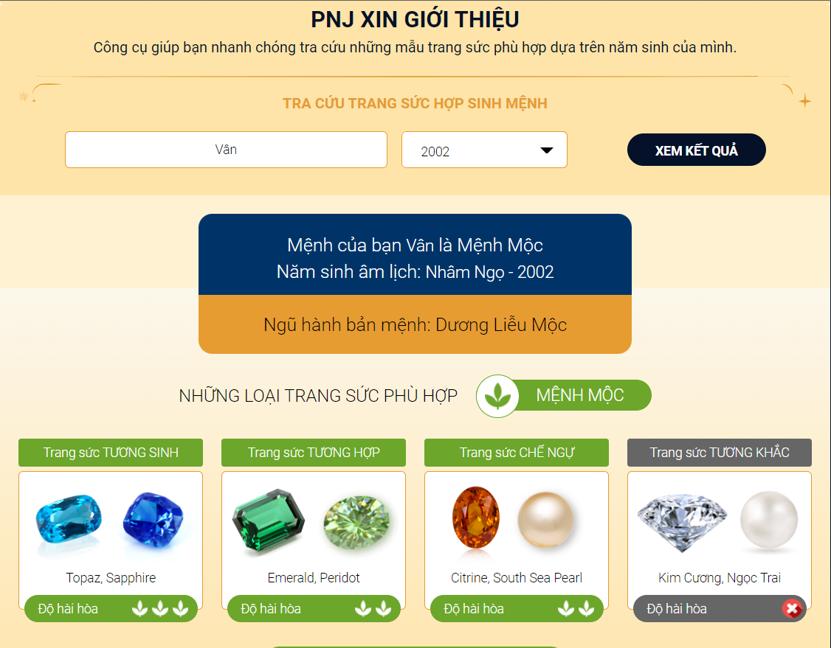

PNJ then obtained the above-expected results from online and offline sales from September to October 2020:

Profit earned on advertising costs (combined online and offline) increased 138 times

10% conversion rate from Messenger to successful transaction

17,000 conversations generated during the campaign



## **3. Strengthen customer and supplier intimacy:**

Customer and supplier intimacy strategy utilizes information systems to develop strong ties and loyalty with customers and suppliers. Parties, customers and suppliers are important to a firm. Strengthening customer and supplier intimacy can be an extremely effective strategy in itself. The information system applications that PNJ uses to create intimacy between customers and suppliers are:

E-CRM:

As an online customer management software, all information related to the business is managed mostly on computers and smartphones, just needing the internet.

Help managers promote products and brands quickly, easily, and cost-effectively. E-CRM is a tool to help businesses manage their business staff in the most effective and focused way.

Help managers compare the business situation from the past, and present to predict the future, thereby easily detecting potential difficulties and risks to promptly offer appropriate solutions.

E-CRM also helps managers evaluate the business situation and work efficiency of each employee. Set up, manage, and track all information about the most effective marketing campaign.

ERP:

Enterprise resource planning (ERP) is a process used by companies to manage and integrate the important parts of their businesses. Many ERP software applications are important to companies because they help them implement resource planning by integrating all of the processes needed to run their companies with a single system. An ERP software system can also integrate planning, purchasing inventory, sales, marketing, finance, human resources, and more.

PNJ has used E-CRM and ERP in the “win feeds win” to develop strong relationships and loyalty with customers and suppliers. When customers were limited to travel, PNJ transformed the multi-channel retail system, and successfully operated the ERP - SAP 4HANA system to manage and maximize the potential of resources. Big Data is included in analyzing consumer trends and improving the CRM system. Enterprises also apply AI to the production process, and put AI-applied camera systems in stores to collect and provide data for customer behavior analysis.

## **4. Product differentiation:**

Use information systems to enable new products and services, or greatly change the customer convenience in using a company's existing products and services.

Along with the flow of time, businesses, especially small and medium enterprises, partly understand the importance and the way that messaging technology is changing human communication. In 2020, the total daily conversation between businesses and users on the two platforms Messenger and Instagram has increased by more than 40% (survey by auditing firm Deloitte). As more and more people choose to shop through social channels, businesses will create conversational technologies that help them connect more and more effectively with customers.

With PNJ, by launching Charmy, an automated experience built on the Messenger platform, PNJ was able to engage in personalized conversations with customers, responding to inquiries and recommendations. Introducing high-end products with the same thoroughness and dedication as consulting directly at the store. In just one month, from September to October 2020, the dialogue commerce strategy helped PNJ increase sales in both traditional and online channels, with about 17,000 conversations established throughout. campaigns, reaping 138 times more profit than ad spend, and achieving a conversion rate from Messenger to successful transactions of up to 10%. As a result, in the whole year of 2020, PNJ achieved revenue of 17,511 billion dong, net profit of 1,069 billion dong, of which, PNJ's profit in the fourth quarter of 2020 reached a record high in history.

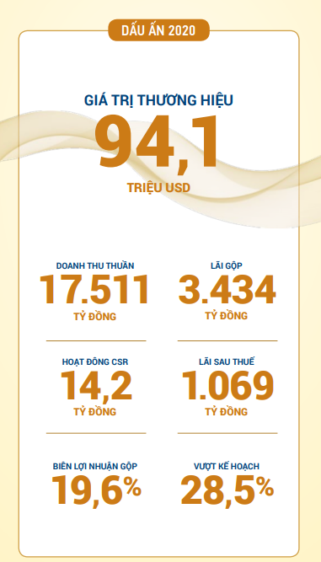

During Covid, PNJ always has proactive plans, during this time, PNJ always "keeps warm'' relationships with customers, has smarter tools in taking care of customers more thoroughly, applying AWS's cloud helps to "smooth" the PNJ website system, which means the user experience is much better than before. In the second quarter of 2021, online sales of PNJ's omni-channel sales increased by 3.16 times over the same period.

During the time of travel restrictions, PNG promotes the Click and Collect model - customers can order online and have not yet paid, and then receive appointments by phone. Customers can like a product, they go to the website to pre-order, then buy at the store. Sometimes customers don't even need to know exactly what product they want to buy. They have a budget to spend on jewelry, they can schedule an appointment with PNJ, everything will be personalized. All have helped PNJ boost sales during this difficult time.

Moreover, PNJ offers speedy, convenient, secure and careful services, making services as strong competitive points:

• Professional website layout, highly comprehensive and convenient to navigate.

• Online shopping, PNJ membership, loyalty card and online membership accumulative point system.

# Explain the basic concepts

## **1. What Is Digital Marketing?**

The term digital marketing refers to the use of digital channels to market products and services in order to reach consumers. This type of [marketing](https://www.investopedia.com/terms/m/marketing.asp) involves the use of websites, mobile devices, [social media](https://www.investopedia.com/terms/s/social-media.asp), search engines, and other similar channels. Digital marketing became popular with the advent of the internet in the 1990s.

Digital marketing involves some of the same principles as traditional marketing and is often considered a new way for companies to approach consumers and understand their behavior. Companies often combine traditional and digital marketing techniques in their strategies.

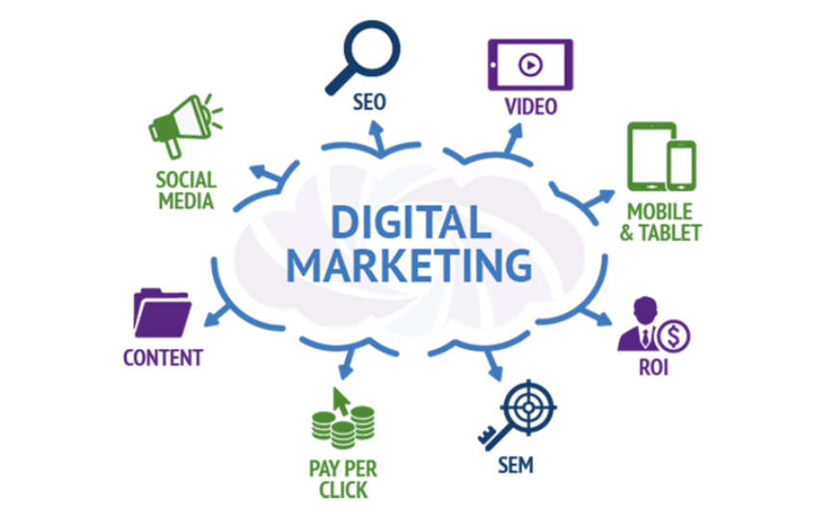

## **2. What is e-marketing?**

E-marketing is an advertising discipline that includes all marketing activities conducted by a business online using an electronic device or the internet. Other names for this type of marketing include internet marketing, online marketing, digital marketing or web marketing. Within this framework, a business uses modern media and technologies to attract new customers, keep current customers and build a brand identity. There are many online tools a business can use for e-marketing based on your business goals, products, capacity and target market.



## **3. What is conversational marketing?**

Conversation is defined by the Cambridge English Dictionary (2020) as a dialogue between two or more people in which their views, feelings, and ideas are conveyed, questions are asked and answered, and news and information are shared. We see that data is communicated and that there is symmetry in that the initiative may correspond to both parties at various stages of the conversation.

The term "conversational marketing" refers to marketing that communicates with customers. This can be accomplished via live chat, chatbots, voice assistants, and other types of conversational agents. These experiences can be delivered through websites, social media channels, paid advertising, and even in-store or linked smart home devices.



# Analyze and compare three solutions in the market.

**E-Marketing/Digital Marketing:**

E-marketing (Internet marketing or online marketing), or online marketing and known by marketers as digital marketing, is marketing activities for products and services through a global connection to the Internet. Digital customer data and electronic customer relationship management (ECRM) systems also come together in Internet marketing.

E-Marketing of companies:

1. **Shopee**

Shopee easy, safe, and fast buying and selling system via mobile

Shopee is a brand with strong activity on the media advertising front when its strategies are very successful in terms of increasing market coverage. The company's forms are often aimed at brevity, conciseness, easy access to the ears, and above all, easy access to today's users. That is why the company's advertising forms in the overall E-Marketing strategy of Shopee are as follows:

* Viral TVC
* Short, catchy slogan: "Like shopping, surfing shopee"
* Use famous KOLs with a certain amount of coverage
* The distinctive color of the brand impresses the viewers





In addition, there was a method that was also quite popular at that time that Shopee used on Tiktok's social network, Instagram "Advertising". By asking KOCs, KOLs, to link directly with their trading platform, buy products on that platform, then have reviews, and finally give customers a link to their products.

Deeper analysis of Shopee's E-Marketing strategy show thrives through versatile online distribution channels. Shopee has continuously updated and released applications exclusively for smartphones and tablets. Furthermore, there is a website that runs on a computer browser. All of Shopee's commerce channels bring many benefits and very good experiences for customers and product suppliers. Help them access purchases, and register sales anytime, anywhere.

The form of affiliate marketing (Affiliate Marketing) is also promoted by shopee to increase the number of large customers for the company. With this form, not only can marketing partners earn more commissions from successfully referring customers to buy products; but also helps shopee to save maximum marketing costs (This case is similar to the case of linking KOLs, KOCs of other trading floors).

1. **Vinfast:**

With a comprehensive communication strategy, Vinfast implements the method of "total attack and rise" on all forums. Specifically, Vinfast's marketing strategy directly targets domestic and foreign communication channels and social media channels. It is thanks to the factor of accurate customer positioning plus the understanding of Vietnamese users' psychology. Vinfast quickly blocked Social Media. The company received 90% positive feedback thanks to the amount of Seeding on social networks. In particular, when asked about Vinfast, 80% of the answers were "know".

Vinfast has made full use of communication channels. Leveraging strategy through events at the “Paris Motor Show”.



“Bridge of Influencer First and Second in the World”

The key point in Vinfast's marketing strategy is here. The company already has a product expansion strategy to compete with major global brands. Vinfast media only revealed that the company had put a lot of effort into inviting international stars to participate in this launch event. Therefore, it makes Vietnamese people even more excited because there is a world famous person to represent the Vietnamese car brand.

Besides, VinFast also invited Miss Vietnam 2018 Tran Tieu Vy, model Tran Quang Dai, Vietnam 2017 runner-up Hoang Thuy... and many major media companies in the world to appear at the Paris Motor Show. These are all people with great influence and popularity at home and abroad.



Each brand has its affirmation journey and strategic steps. Victory lies in who understands the market needs better and who knows how to navigate the most comprehensive strategy. Understanding the importance of Social Media, VinFast has also taken advantage of social networks to promote its brand and attract customers.

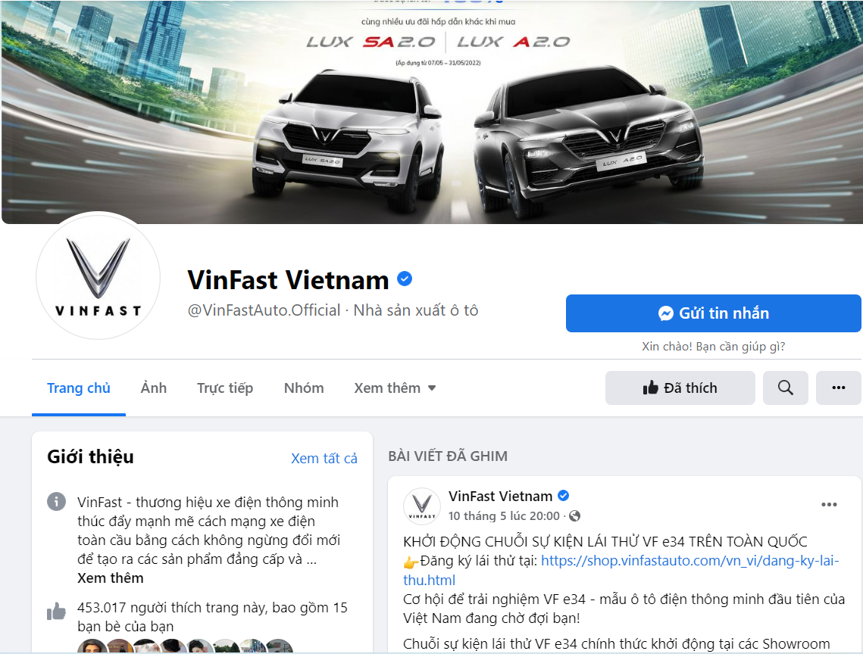

VinFast's marketing strategy is to hit the media on social networks - where Vietnamese users are mostly used to approach and promote the brand. For advertising and communication campaigns, VinFast has taken advantage of social networks to promote and increase its brand awareness. Recently, VinFast's TVC advertisement was broadcast on CNN channel by AKQA - the world famous media company behind million-dollar publications of famous car brands.

1. **Vinamilk**

We all know that customers are spending more and more time online. And Vinamilk understands consumer insight and has seen the opportunity to drive customer awareness towards itself with digital.

#### 

#### 

To reach out to women, especially mothers, with content close to them, the brand used 3 steps including: Youtube strategy, creating interaction and making long videos with targeted content. customer insights. By capturing content trends and investing in online videos, Vinamilk's brand awareness has increased and became the first consumer packaged goods (CPG) brand in Southeast Asia to reach 1 million visitors. follow on Youtube.

Vinamilk decided to develop engaging, family-oriented content using the strategy of “hero, hub, help”, a new form of customer outreach for Vietnamese brands.

*Hero*

In order to better interact online with Vietnamese women, Vinamilk prioritizes investing in and creating videos that capture music trends and invite famous personalities on YouTube such as actors Huynh Lap and Thu Trang. To ensure initial growth and visibility, each piece of foundational content (hero) is invested in running Youtube mastheads and TrueView video ads.

#### 

Hub



In order for viewers to keep coming back for more, keeping the attention of mothers and babies, Vinamilk has developed video series such as: video series of children's songs and series "Clean farm". Because Hub content has the ability to attract a higher number of followers, Vinamilk spends less advertising money on these series.

*Help*

Vinamilk also creates content that provides great tips for parents. For example, a cooking series called Delicacies from Vinamilk. To provide cooking instructions when customers need.

By strategizing ad spend on YouTube to regain initial investment and optimizing video titles, thumbnails, data tags (metadata) and playlists to increase organic views, 🡪 Vinamilk saw his YouTube subscriber increase dramatically.

# Describe values of implementing information system solutions for management and business growth.

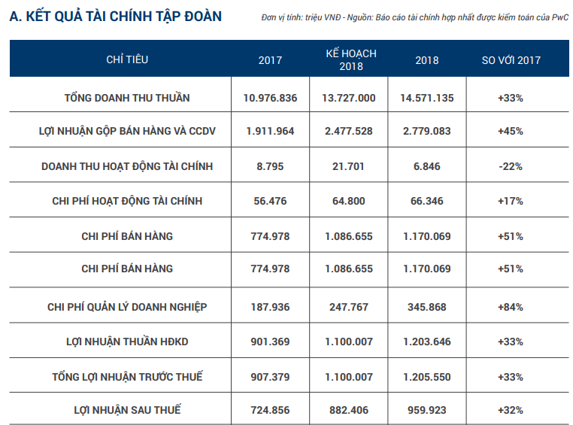

(Assessment of business results in 2018)

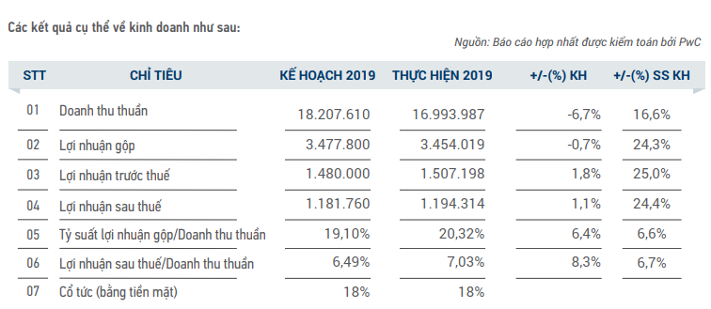

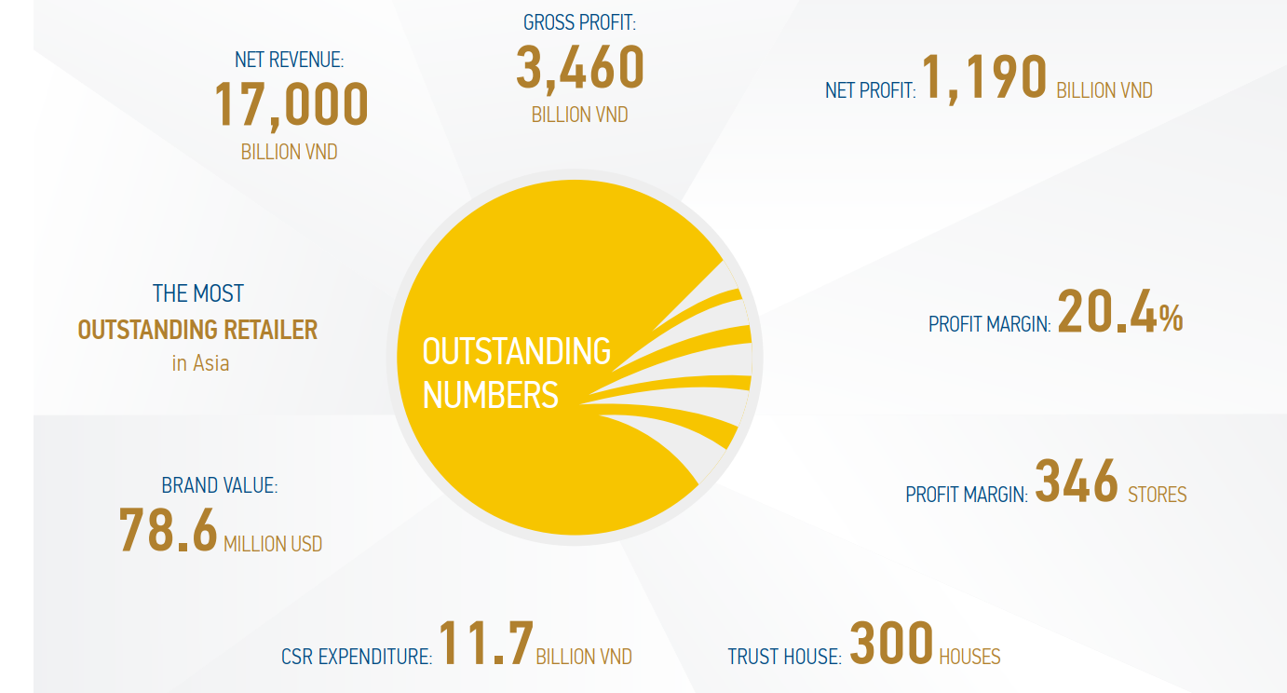

(Assessment of business results in 2019)

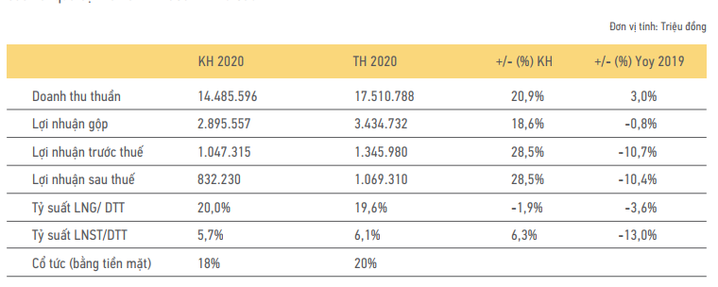

(Assessment of business results in 2020)

The corporation's gross profit reached over 3,400 billion, equivalent to 2019. The consolidated gross profit margin for the whole year reached 19.6% and continued to remain at a high level compared to previous years. This is especially meaningful in a year of continuous difficulty due to the pandemic, social distancing, and a sharp drop in consumer demand; it reflects the determination, efficiency, and internal strength of the whole corporation. 2020, Announcing a new vision, officially becoming the Best Jewelry Enterprise in Asia - Pacific, valued at $93.1 million by Forbes Vietnam.

# E-Marketing/Digital Marketing from PNJ and their still existing problems.

In terms of Digital Marketing of PNJ, taking advantage of the use of social networks such as Facebook, Instagram to run ads, increase brand awareness to customers. In particular, the communication campaigns are invested with quality for each message, season, and holiday, helping to maintain and attract the most attention of customers in the fat online market. The ingenious flexibility of inserting messages into each campaign sent to customers has made many big wins in the jewelry industry that make the opponent have to learn.

It can be said that PNJ's communication campaigns always know how to delve into the psychology of customers. Specifically, the campaign “Golden Happiness” or “Priceless Gift”…. These campaigns have brought about very positive results for the number one jewelry company in Vietnam, helping the company increase its market share and reach a very large percentage.

With the "priceless gift" media campaign, all videos shot with realism and story lines will resonate with PNJ's viewers, and at the same time, convey PNJ's view that women are invaluable. price and deserve the best. With a lot of comments expressing consensus from viewers and discussions about the story in the clip, we continue to attract users on Facebook to the microsite. The microsite reached a total of 221,595 participation with only 30% of the media budget. The video became an instant hit online with a total of 2,596,525 views, 18,533 shares, and over 33,000 interactions and 1.5 million views on the PNJ fanpage alone. "Social media'' is a tool for the company to attack customers, the young age group is the customer market that PNJ's marketing strategy is aimed at. Moreover, communication tools have helped PNJ get closer to jewelry-loving customers.

In addition to the popular and popular campaigns above, recently PNJ has also launched a mini game CHALLENGE 6 DAYS 6 NIGHT SHARE LOVE MV WITH PNJ which is extremely suitable for current youth trends. This is really one of the biggest challenges in big companies like PNJ, when it comes to changing their marketing thinking, how to accept and keep up with the new trends of young people, and how to turn it to your advantage. It requires not only the innovative thinking of the leaders but also the creativity and agility of the marketers, PNJ really has it all.



In addition, PNJ also regularly organizes minigames to get closer to customers and find new customers. A recent highlight is the minigame "Gamification Marketing" which is one of the approaches to realize self-spreading communication, giving 100% of customers the opportunity to receive New Year's gifts. Not only that, for each share of the God of Fortune, the Company will deduct 5,000 VND for charity activities in 2022. After the program, more than 100,000 customers participated, shared and accompanied the campaign. With this approach, PNJ is not only bringing a positive message, but also the companions and customers who use the brand's products are also becoming inspirational people.

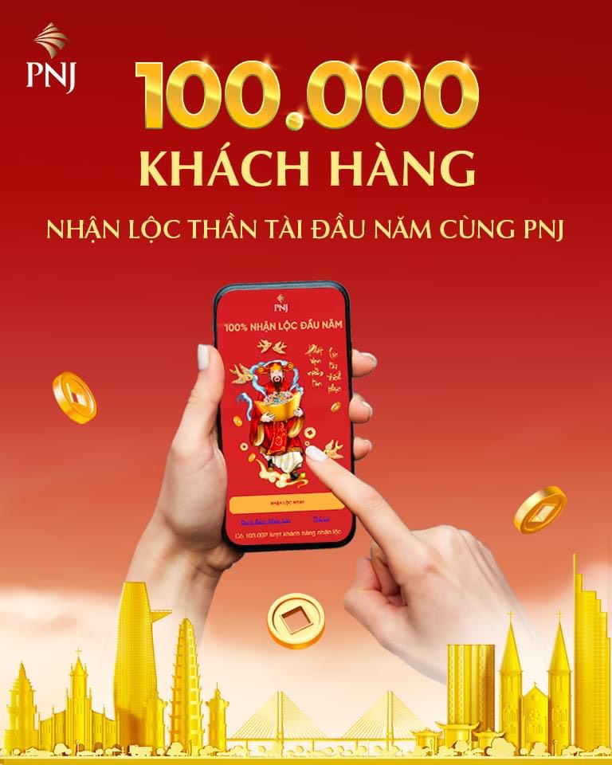

In general, the digital marketing of PNJ, a business that sells non-essential products, is really good. Despite being the leader, PNJ does not rest on its achievements, but we clearly see that PNJ's campaigns are always aimed at expanding market share and finding more new customers. Therefore, the average age of PNJ's customers is gradually shifting from 35 to 30.

However, there are still some resources in this potential - digital environment that PNJ has not been able to fully exploit.

SEO tools have not been focused on by PNJ for its website. Although increasingly upgrading the quality and design of its website, PNJ seems to have forgotten this extremely useful SEO tool.

According to statistics of Google Consumer Barometer (2017), in Vietnam Google is the most popular search engine, accounting for 93.3% of internet users with 3.9 billion visits per month. Google returns the results according to the customer's desire. And to get that result is by doing SEO through many methods and techniques. SEO gives businesses the opportunity to occupy a high position in the Google rankings. When you stand on the first page of this search engine, you will be a business that is known by many customers.

One thing is quite certain, Vietnamese users' psychology before buying often learns quite thoroughly. If they trust an address, they are more than willing to go to the store. With new customers, that trust is also built from SEO. SEO helps put your information on Google, reaching thousands of searchers. Especially with luxury products, customers tend to research carefully on information channels before making a purchase decision.

Grasping that, DOJI Group - DOJI Jewelry Group, one of PNJ's major competitors, has taken full advantage of SEO. DOJI's website always appears at the top when customers have any search related to gold, silver and gems on Google.

In addition, the group realizes that PNJ needs to develop more in the e-commerce segment besides offline store chains to move towards applying O2O to catch the trend and maintain its leading position.

User demand and consumption trends in the gem industry have changed significantly, especially after the impact of Covid-19. In order to compete to retain and expand the customer base as well as to enhance the brand, businesses not only need to satisfy their products and services but also satisfy customers on the journey of experience.

The closures, restrictions on movement between countries and economic uncertainties have reduced the sales of gem and diamond jewelry by businesses, and the customer demand for gemstone jewelry has also become worse. more localization. In addition, the Covid-19 epidemic has accelerated trends that are currently reshaping the diamond industry. The diamond value chain is becoming more digital even though brick-and-mortar stores are still not losing value.

E-commerce is also strongly developed, in 2020, about 20% of retail sales will take place online, in which, diamond jewelry retailers also announced sales growth of 60-70% compared to the previous year. with the same period of 2019 on their online channels. This shows a growing trend in online sales, however, the majority of consumers still prefer to buy diamonds at brick-and-mortar stores because they appreciate being able to see and touch their jewelry together. with direct advice from staff and other accompanying personal services.

However, there is no denying the change in customer tastes, the purchase of goods in online channels and e-commerce platforms is increasing and shows no sign of stopping. Even the diamond and jewelry industry is no exception. Grasping this preeminent benefit, DOJI officially cooperated with the two leading prestigious e-commerce platforms in Vietnam, TIKI & Shop VnExpress, to launch an extremely attractive and convenient jewelry store for customers.

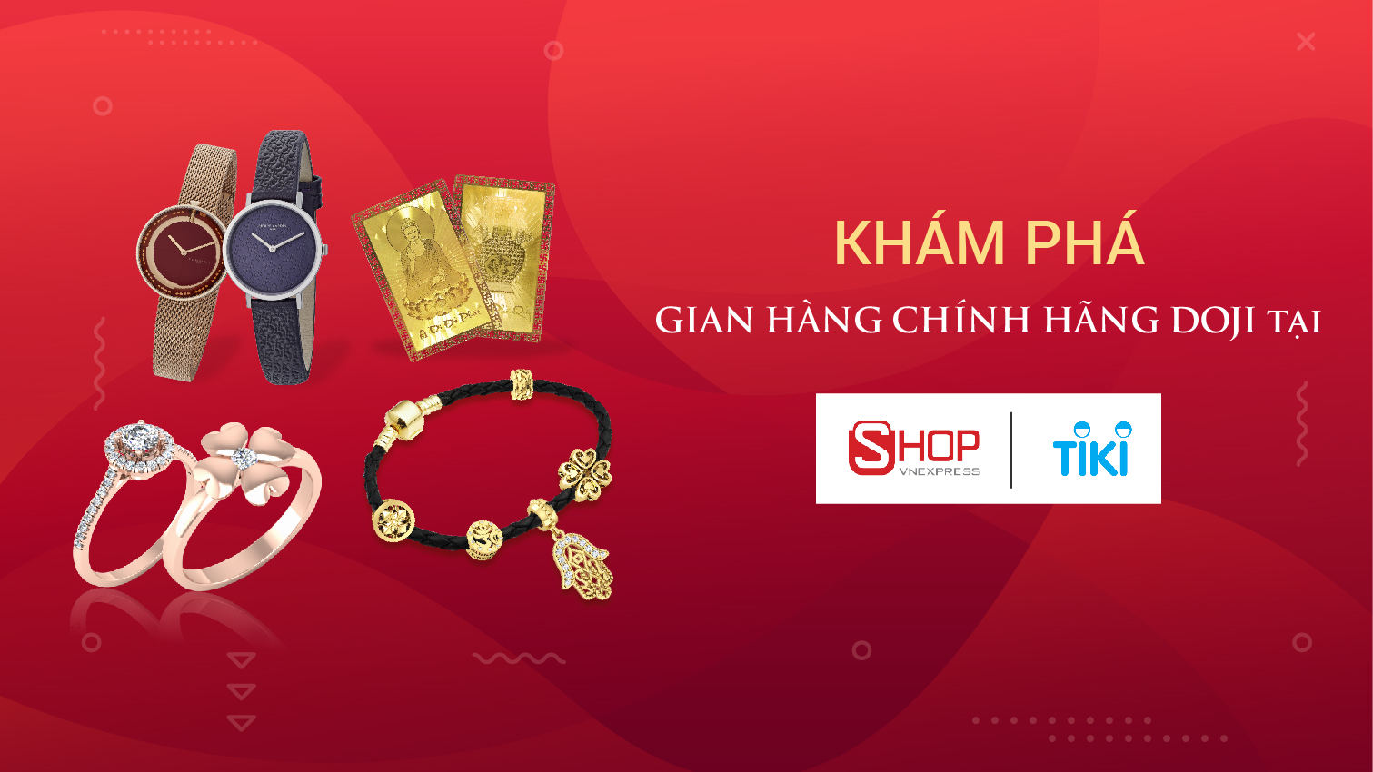

Therefore, pushing to develop more in the e-commerce segment is also very reasonable and in line with the new tastes of customers. In the long run, this will really create a competitive advantage for businesses that know how to grasp.